SIMATS ENGIN EERING
SAVEETHA INSTITUTE OF MEDICAL AND TECHNICAL SCIENCES

EXPERIMENT 02
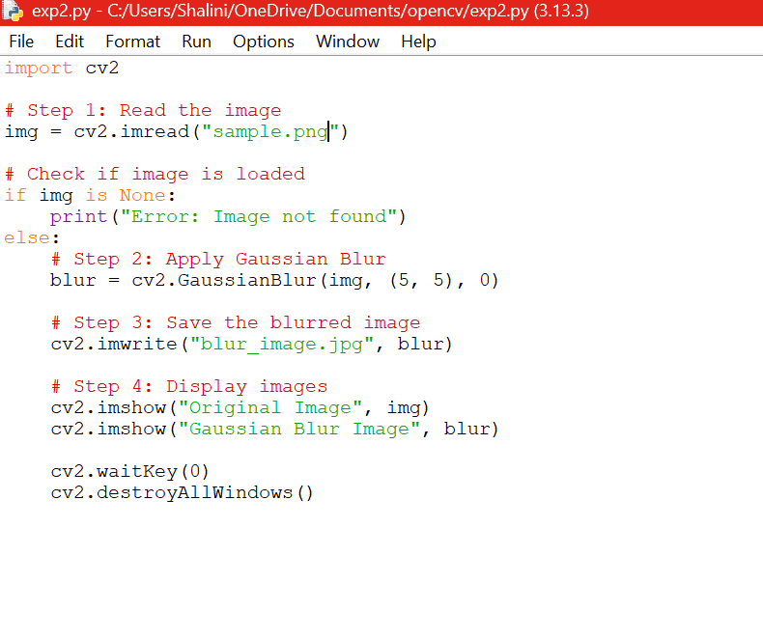
OUTPUT:
